Proposal

Grainger
End of Tenancy

Version 1.0
January 17, 2024
Contents
1 Executive Summary 3
1.1 Introduction 3
1.2 The Business Opportunity 3
1.3 The Project 3
1.4 The Business Benefit 3
2 Proposed Solution 4
2.1 Project Objectives 4
2.2 Sample Screens 5
2.3 Solution Context 9
2.4 Future Functionality 10
2.5 Workflow Design 11
2.6 High-Level Design 13
2.7 Salesforce Licencing 19
2.8 Support 19
2.9 Training 19
2.10 Exclusions and Limitations 19
3 Detailed Costs 21
3.1 Extension of Service Period 22
3.2 Dependencies 22
4 Delivery Approach 23
4.1 UAT 24
4.2 Project Management 24
4.3 Availability 24
5 Acceptance 25
6 Appendices 1
6.1 Appendix A – Backlog for Release 1 1
6.2 Appendix B – Backlog for Future EOT Releases 7

Executive Summary

Introduction
Grainger are planning on significant expansion, looking to double their number of letting homes in the next 3-4 years. The current systems and processes used in managing end of tenancy and voids are not scalable to support this.
As part of the larger Connect platform, Grainger PLC has successfully implemented Salesforce to manage the Lead-to-Lease process. This has transformed both internal operations and the customer journey. Grainger PLC are now looking to leverage Salesforce to realise similar benefits for the End of Tenancy process.
This proposal has been prepared at the request of Grainger and outlines the development of a new End of Tenancy (EOT) process within Salesforce that aligns with Salesforce features and best practices.

The Business Opportunity
Grainger PLC have identified that a centralised, standardised EOT workflow that tracks the end-to-end EOT progress would minimize delays and provide visibility into upcoming work, delays, timelines & responsibilities.

The Project
Open Box will implement a new End of Tenancy process within Grainger PLC’s existing Salesforce org. The solution will be delivered in increments, providing tangible business value on a regular basis.
The solution will automatically notify internal teams of EOT-related tasks to be completed, assign clear responsibility for tasks, and measure timeframes and KPIs against targets.

The Business Benefit
Leveraging the existing Salesforce platform and user licenses will help to:
- Improve speed & efficiency.
- Reduce errors.
- Allow operations to scale without a linear increase in employee headcount.
- Minimize the time that units remain vacant.
- Improve customer satisfaction - reduce the risk of not cancelling direct debits or returning deposits on time & create a single view of customer.

Proposed Solution

Project Objectives
Open Box proposes to implement a new End of Tenancy (EOT) workflow within the existing Salesforce org. The EOT record creates single source of truth for collaboration & tracking of all EOT activities.
Release 1 will address the following objectives:
- End of Tenancy Workflow - Enable users to create & complete an end-to-end EOT workflow once the tenant gives notice to quit.
  - The workflow would consist of phases, and tasks to be completed within each phase. Tasks would be automatically assigned to the appropriate team to complete.
  - Users would manually indicate when tasks are complete, or if a task is not applicable for a particular EOT.
- Calculate EOT Timelines – Automatically calculate and update estimated timelines, including expected start and completion date for each task as well as the date the unit will be available for relet, based on the latest EOT information.
- Task Lists – Provide EOT -related task lists that will notify users and teams of upcoming work, as well as tasks that are ready to be worked on.
- Update Unit - Automatically update Salesforce unit data (such as unit status and future vacate date) with EOT-related information, once key EOT milestones have been met.
- Building View - Provide a view of current & prior EOTs for a unit, as well as all current EOTs for a building.
- Upload Documents - Enable users to upload EOT-related documents and access those documents when viewing the EOT or associated tasks.
- Property Calendar - Display a calendar per property of all onsite EOT tasks that will assist property management in scheduling onsite work.
- Reports & Dashboards – Provide reports and dashboards that give visibility into EOT-related KPI's (actual vs target timelines), overdue tasks, EOTs behind schedule, as well as workload for users and teams.
- Replace Internal Notification Emails – Notify internal teams and users of new EOT of interest to them and associated responsibilities, through EOT tasks and dashboards.
- Audit History – Enable users to see a history of updates to EOT and underlying tasks.

Sample Screens
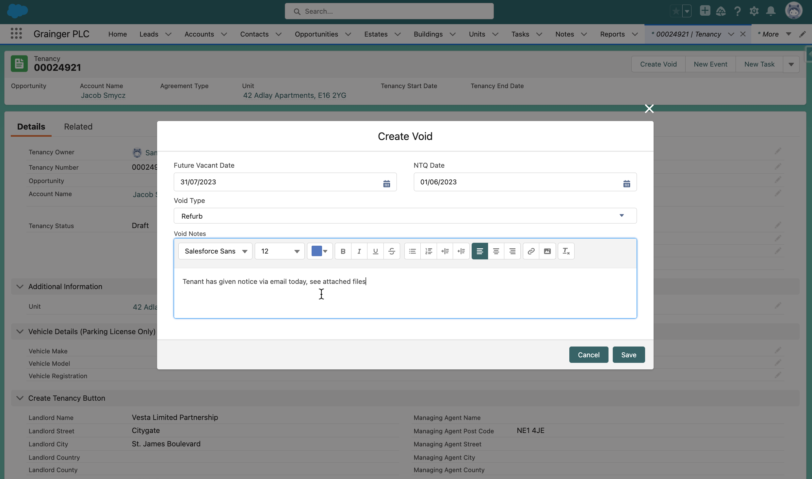
Figure 1: Sample Screen – Initiate a New EOT from the Relevant Tenancy
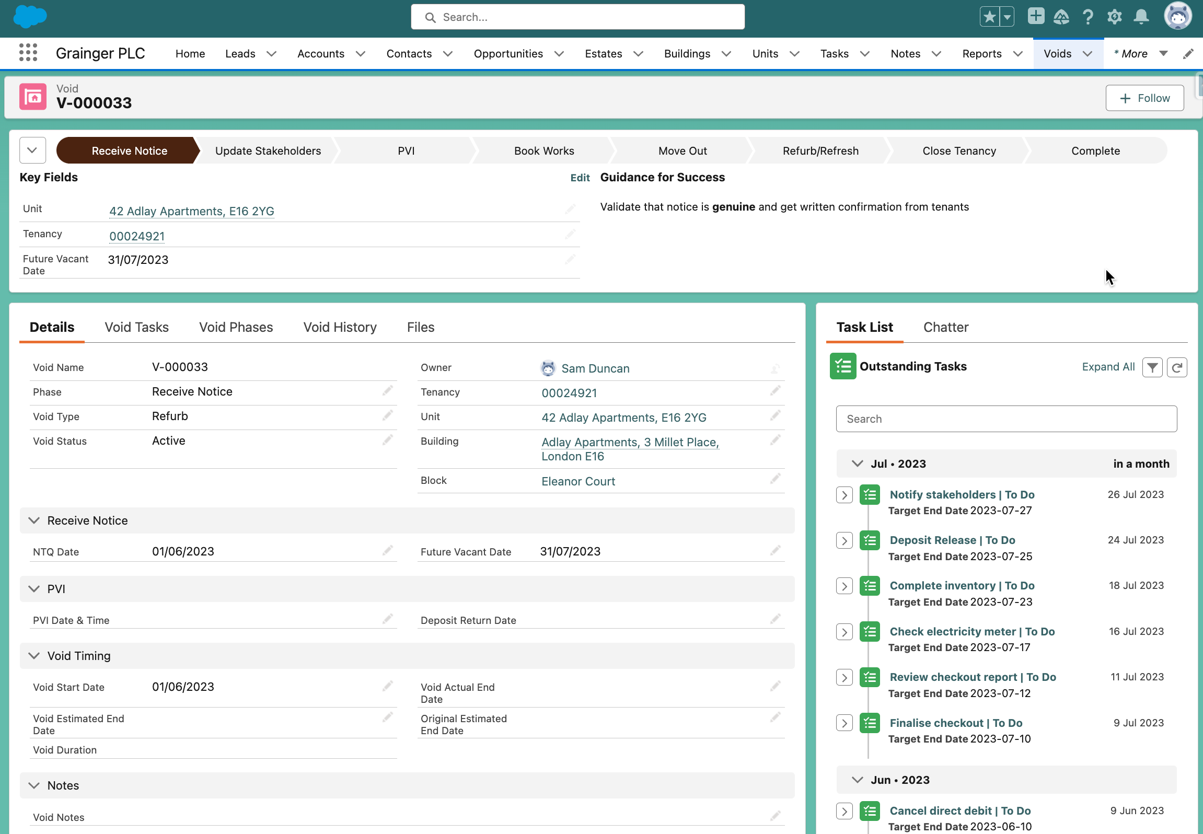
Figure 2: Sample Screen – EOT Details & Automatically Task Timeline
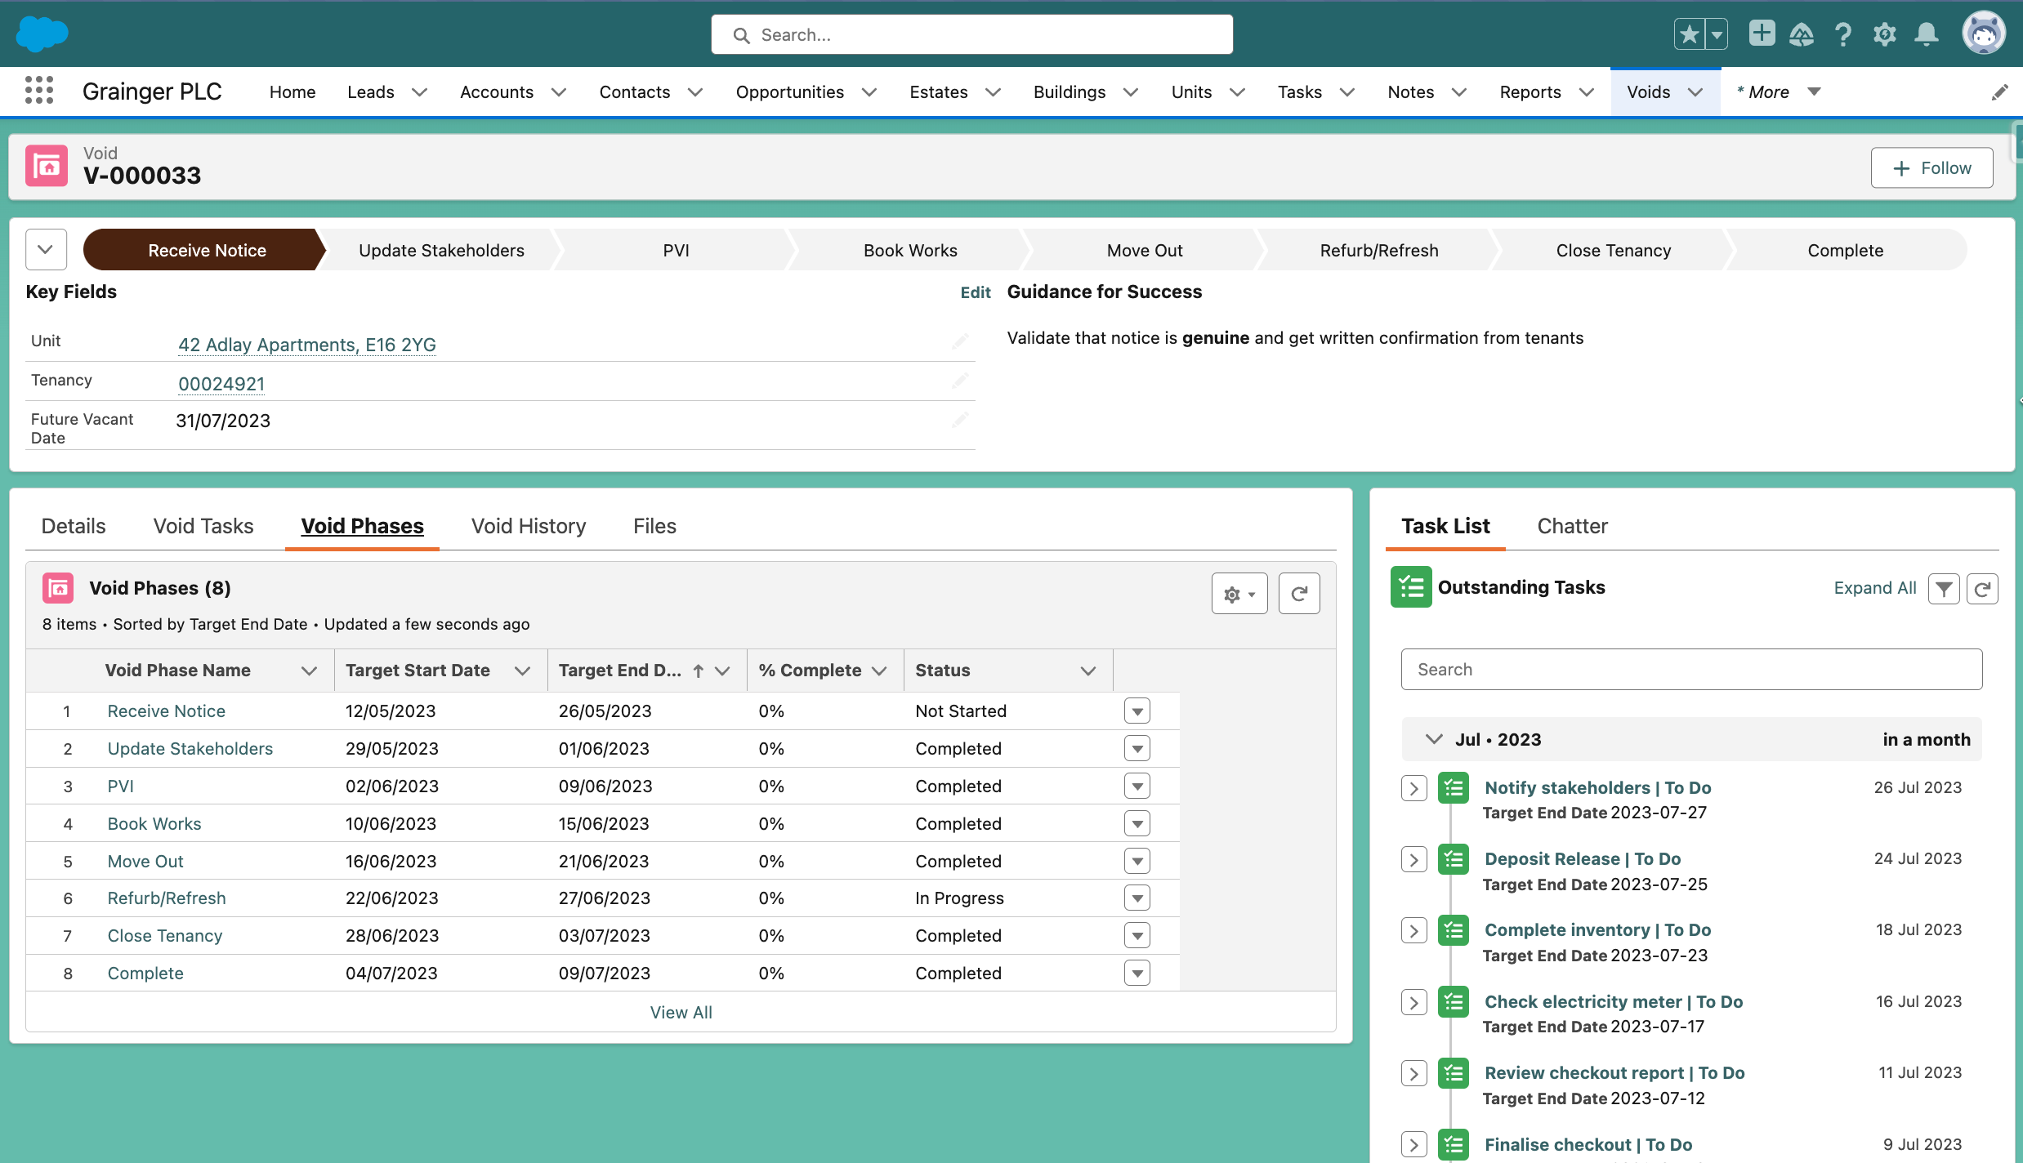
Figure 3: Sample Screen - Phases with Projected Start & End Dates
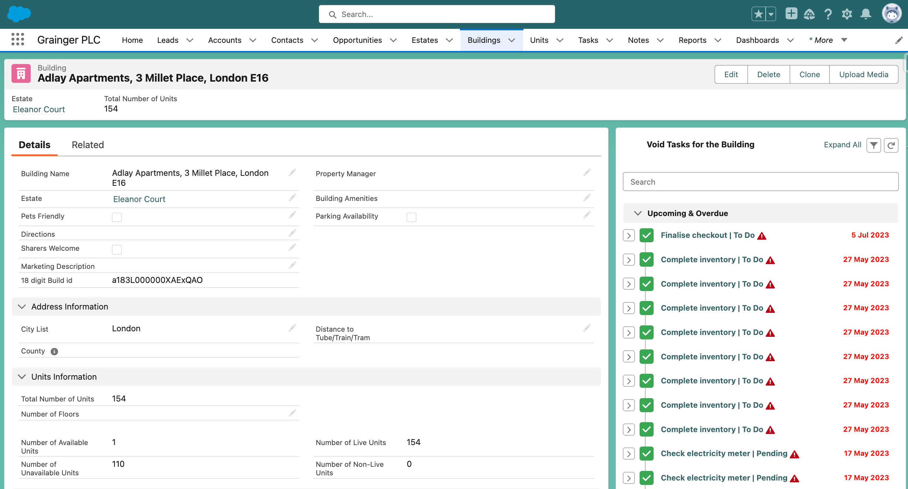
Figure 4: Sample Screen - Consolidated View of Tasks at Building-Level
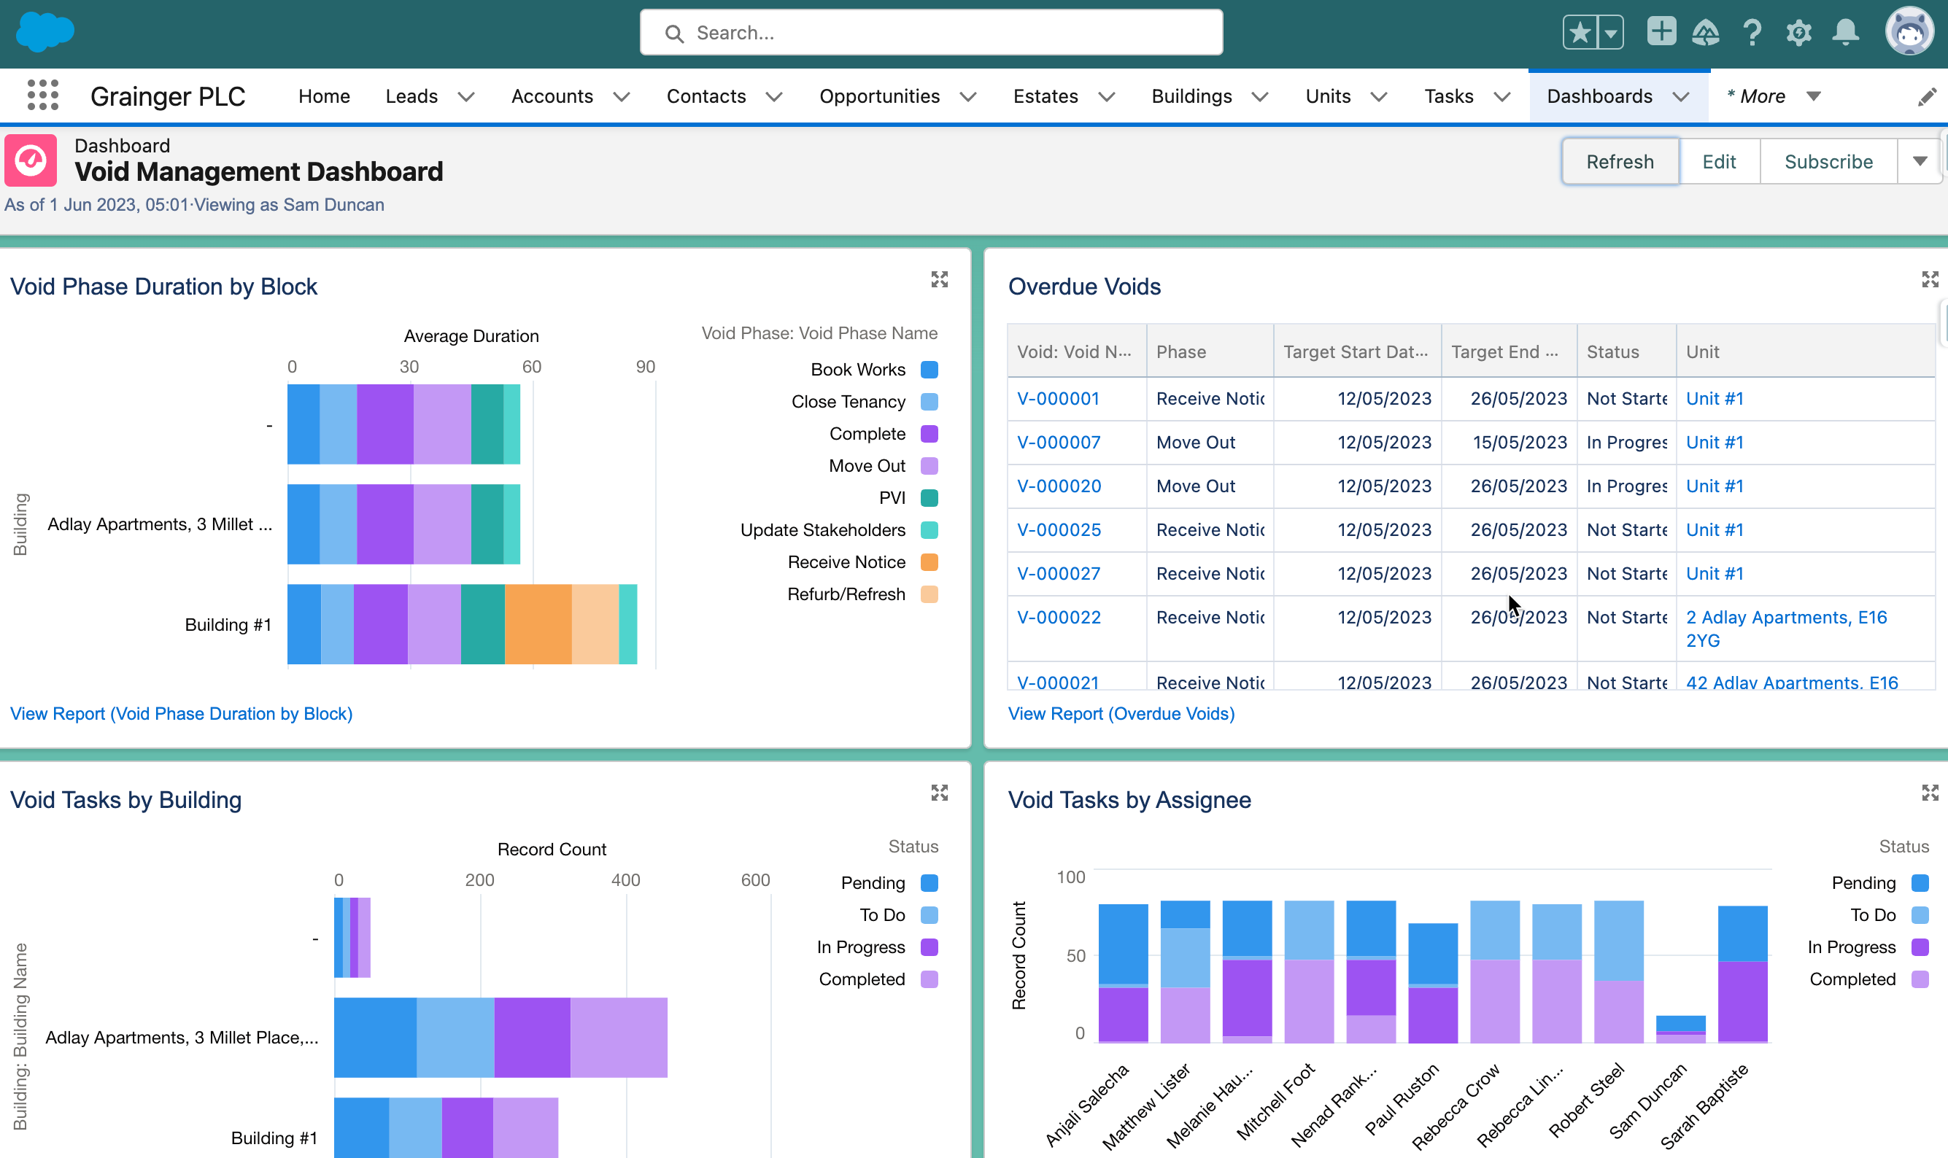
Figure 5: Sample Screen - Reports & Dashboard
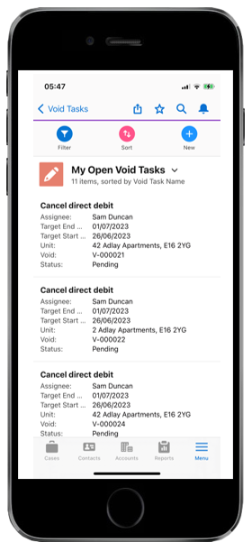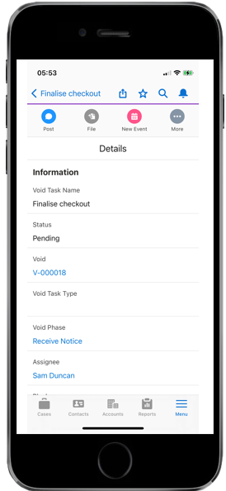
Figure 6: Sample Screens – Complete Tasks & Attach Photos on Mobile App

Solution Context
The following provides an overview of the solution’s interfaces and users:
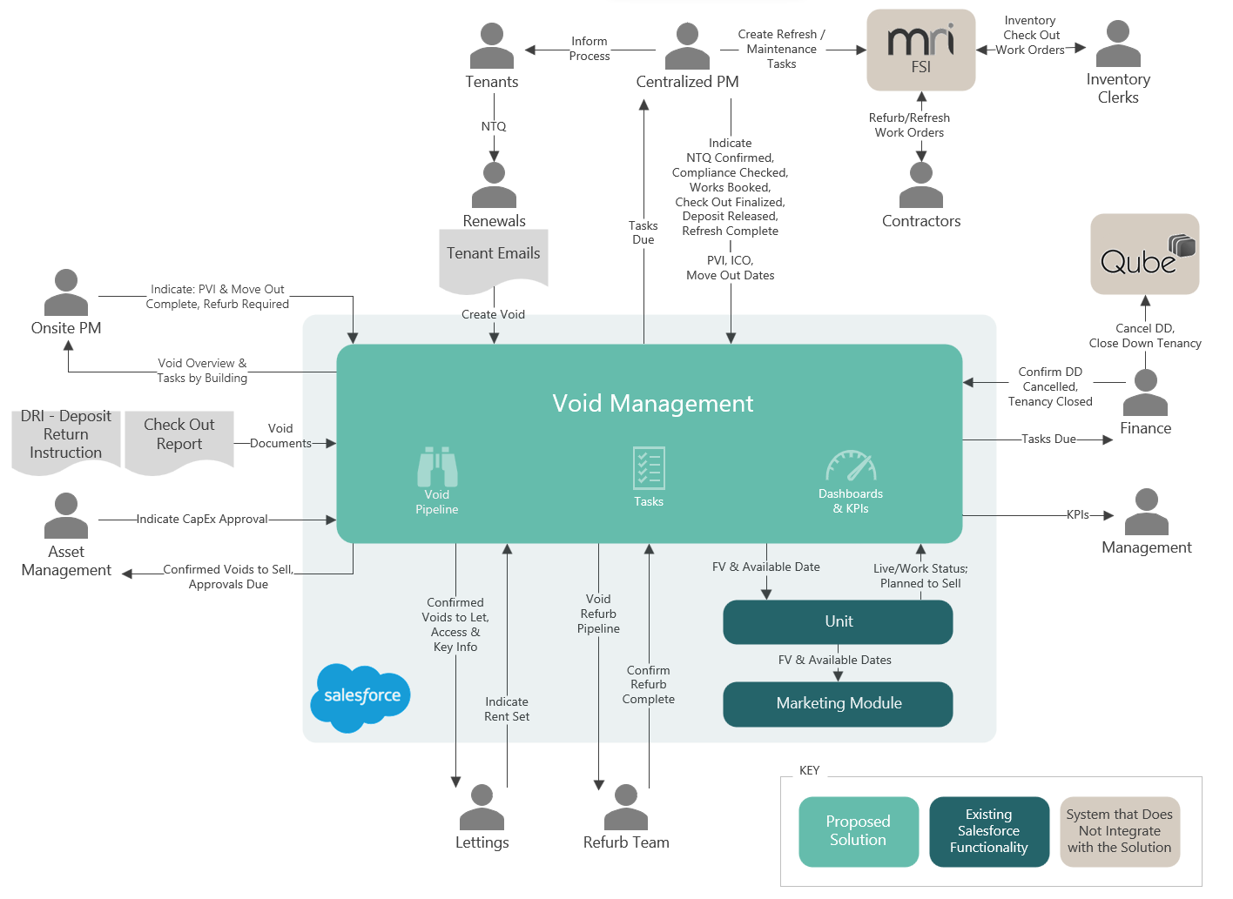
Figure 7: Proposed Solution Context (Release 1)
- Void Management – The solution will be implemented entirely within Salesforce; there will be no direct integration with other systems, other than to utilize Qube data and any other data that is already synced with Salesforce.
- Internal Teams - Users will monitor task lists and other EOT pipeline views, and manually indicate when the EOT-related tasks for which they are responsible are complete.
  - Users may also upload relevant documents & emails to the EOT object.
  - External users, such as tenants or contractors, will not have access to the solution initially.
- Unit - The Salesforce unit data will be kept in sync with the EOT data. The unit provides key information such as the live/work status that informs the EOT process, and the EOT process will update key unit information such as future vacant and available date.
  - While the existing marketing process is not directly integrated with the EOT solution, by keeping the unit’s future vacant and available dates up-to-date, the existing marketing process will be triggered for new EOTs.

Future Functionality
Additional functionality that is not included in the initial project scope as outlined above, but which may be addressed in future project releases (see Appendix B – Backlog for Future EOT Releases) includes:
- Integration with Qube, FSI or other data sources.
- Incorporating expected delays into timelines.
- Custom, user-defined tasks.
- Capturing detailed works required and creating resultant tasks.
- Detailed refurbishment tasks
- Replacing the existing PVI checklist.
- Uploading compliance certificates and EPCs with expiration dates.
- Online tenant instructions, such as notice to quit and deposit return instructions.
- Advanced dashboards including trends & comparison analysis.
- Incorporating viewings & non- EOT activities into the property calendar.
- Customising turnaround times
- Catering for non-working days.
- Automated emails to tenants (including move out emails).
- Multiple EOT workflows – including garage/parking bay EOT, tenant has already vacated, landlord gives notice to vacate, tenant rescinds notice to quit.
- Automatically assigning tasks to individual users.

Workflow Design
The proposed solution will provide a configurable framework that allows for multiple EOT workflows in future, where each workflow may have different phases, underlying tasks, sequence of tasks, and/or expected task duration.
The initial release will provide an EOT workflow for the scenario where a tenant provides advance notice to quit.
The following depicts the configuration of phases and tasks in the initial workflow:
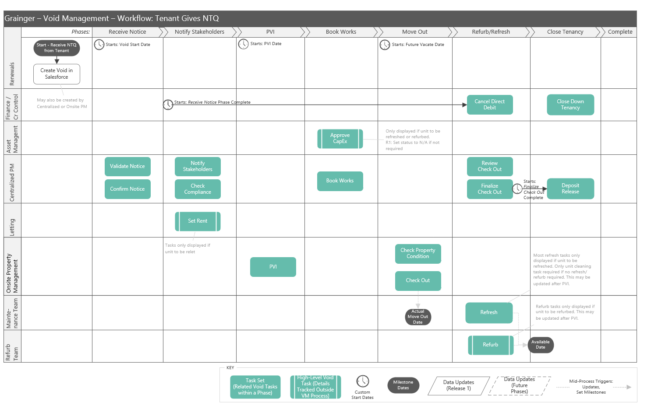
Figure 8: EOT Workflow Diagram – Tenant Gives Notice to Quit
The proposed framework and EOT workflow would function as follows:
- Create an estimated timeline of work on creation of an EOT
  - On creation of an EOT, phases and underlying tasks will be generated based on a template. An estimated start & end date is calculated for each task based on:
    - EOT dates – Certain tasks start on the EOT start date, PVI date or FV date.
    - Phase completion – Certain tasks start once a prior phase is complete.
      - Tasks such as Cancel Direct Debit may start out of sequence, when a much earlier phase is complete.
    - Task completion – Certain tasks, such as Deposit Release, will start once a specific, preceding task is complete.
  - Each task is assigned to a team.
  - Phases automatically close once all underlying tasks are complete.
  - The next phase & underlying tasks (that do not have a custom start date) automatically start once the prior phases closes.
- Update estimated timelines as additional information becomes available
  - Estimated dates (and unit available date) are recalculated as preceding tasks are completed and as key information (such as PVI & FV dates) are captured or updated.
  - Tasks specified as N/A for a particular EOT will not be included in timeline.
  - Set Rent – Certain tasks will only be displayed where the unit is flagged to be relet, and will be removed from the workflow where this indicator is changed.
  - Refurb / Refresh – Certain tasks will only be displayed where the unit is due to be refreshed; other tasks will only be displayed where the unit is due for refurbishment. This indicator may be changed during the EOT process and the associated tasks will be displayed/hidden accordingly.
- Enable users to see when a task is ready to be worked on
  - Tasks will be automatically updated from ‘Pending’ to ‘Active’ status once they are ready to be worked on.
    - The actual task start date is set, from which KPIs can be measured.
    - The estimated end date is updated so that the user knows the timeframe in which they are expected to complete the task.
  - Tasks appear in user’s task list based on the actual start date; not based on current phase. I.e. Work can start on tasks in future phases.
- Measure time actually taken & provide KPIs
  - Actual start & end dates for each task are saved and can be compared to the expected duration for key tasks, a set of related tasks or a phase.

High-Level Design
This document provides a high level design for the proposed Void Management solution to be implemented on Grainger PLC’s Salesforce org.
The design is intended to establish the key architectural decisions that will underpin the solution and ensure that it adheres to the 3 key principles of the Salesforce Well-Architected Framework:
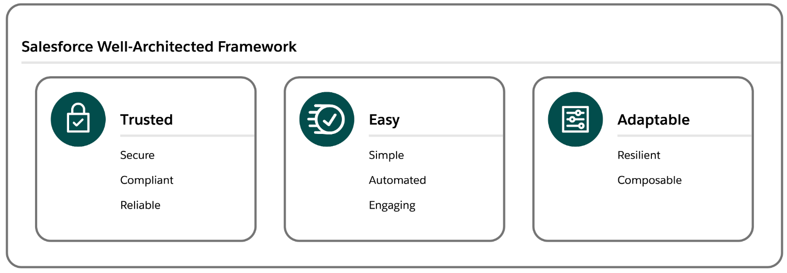
- Trusted solutions protect stakeholders
- Easy solutions deliver value fast
- Adaptable solutions evolve with the business.
This design does not cover the lower level detail (e.g. fields, profiles, automations, validation rules) – these will be designed and documented at user story level during the agile implementation phase.

Salesforce Strategy

Org Info
The Grainger PLC Salesforce org was provisioned in October 2019. It is an Enterprise Edition org with single GBP currency. There are currently 210 Service Cloud licenses, 25 Platform licenses and 40 Partner Community licenses assigned to the org.

Org Strategy
At this point in time there are no requirements (e.g. data residency, large data volumes, autonomous business units etc.) that would require a multi-org strategy, thus the Void Management process will follow a single org strategy and will be implemented on the existing Grainger PLC Salesforce org. Among other benefits, a single org provides the best solution to easily deliver unified processes, a single view of the customer and lower total cost of ownership.

Document/File Management
It is understood that the current document management system (DocuShare) is being retired in June 2024, currently with no replacement having been identified. It is recommended that the Void Management Process make use of Salesforce Files to manage the various documents that are collected and collaborated on. Salesforce Files will allow documents to be attached in context to the records they relate to – e.g. photos of damage to paint work may be attached to a task being created to book maintenance work. This allows easy collaboration and sharing across the multiple teams that are involved in the Void Management Process.

Archival Strategy
Salesforce file and data storage capacity is limited and is determined by a base allocation at org level plus a per-user allocation. Any overage will require the purchase of additional storage from Salesforce. Additionally for data (i.e. records rather than files), a high number of records of any one object can result in large data volume (LDV) performance limitations (report timeouts, slow page loads etc.). Thus it is desirable to operate within the allocated capacity if possible and implement an archival strategy to move data and files off-platform at a point in time where users no longer need to interact with them.
In order to calculate data and file volumes, the following assumptions have been used:
- Number of units: 13 000 in year 1, scaling to ±30 000 in year 5
- Number of voids per year: 1 void per unit
- Number of tasks per void: 40
- Number of files per void: 10
- Average file size: 2MB
Based on these assumptions, the table below shows predicted data and file storage requirements.
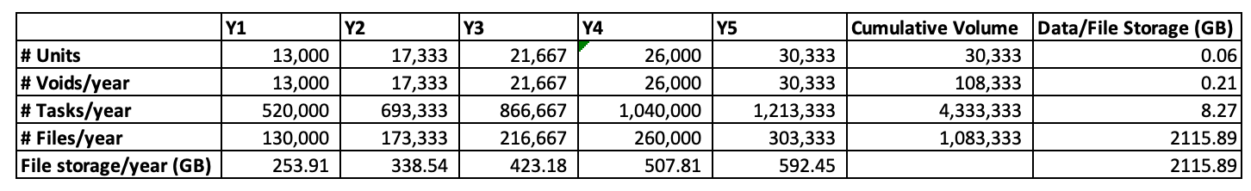
Table 1: Projected File and Data Storage

File Archival
Grainger PLC’s Salesforce org currently has a 503GB file storage limit, of which 66GB is already used. Based on the projected volumes above, this limit would be exceeded in the second year of operation. While not required for the go-live of the Void Management solution, it is suggested that an archival policy be considered so that files can be automatically moved (e.g. via GREP) from Salesforce to a more cost effective storage solution (e.g. SharePoint). Files should be archived at a point in time where users no longer need to interact with them directly from Salesforce, for example 6 months after a void has been completed. File-specific policies may also be implemented, for example the inventory pdf may be retained on the Salesforce platform for longer than photos of painting works.

Record Archival
Grainger PLC’s Salesforce org currently has a 14.8GB data storage limit, of which 7.5GB is already used. Based on the projected volumes above, the data storage limit is likely to be exceeded within the next 5 years. While not required for the go-live of the Void Management solution, it is suggested that an archival policy be considered so that records can be automatically moved (e.g. via GREP) from Salesforce to a more cost effective storage solution (e.g. Azure SQL). Records should be archived (or deleted) at a point in time where users no longer need to interact with them directly from Salesforce, for example 6 months after a void has been completed. Object-specific policies may also be implemented, for example Void records may be retained on the Salesforce platform for longer than the tasks that relate to the void.

Archival Strategy Recommendation
There is no need for the immediate implementation of any archival strategy. Given that the above calculations are based on assumptions, it is recommended that volumes be monitored during the course of operations. Based on actual record volumes a suitable archive strategy and timelines can be planned.

Mobile Strategy
It is recommended that the Salesforce Mobile App be used to provide mobile access where required. There are no offline, branding or native device capability requirements that would necessitate any custom mobile app development.

Reporting Strategy
Operational reporting needs can be met via Salesforce reports. Should deeper analytical capabilities be required in the future, these can be met via a BI solution such as Power BI coupled with an Azure SQL data warehouse.

Add-Ons / Appexchange Apps
No additional add-ons or AppExchange apps are required for this solution.

Data Model

Entity Relationship Diagram
The Void Management solution high-level data model is shown below with existing standard and custom objects as already implemented in the Grainger PLC Salesforce.
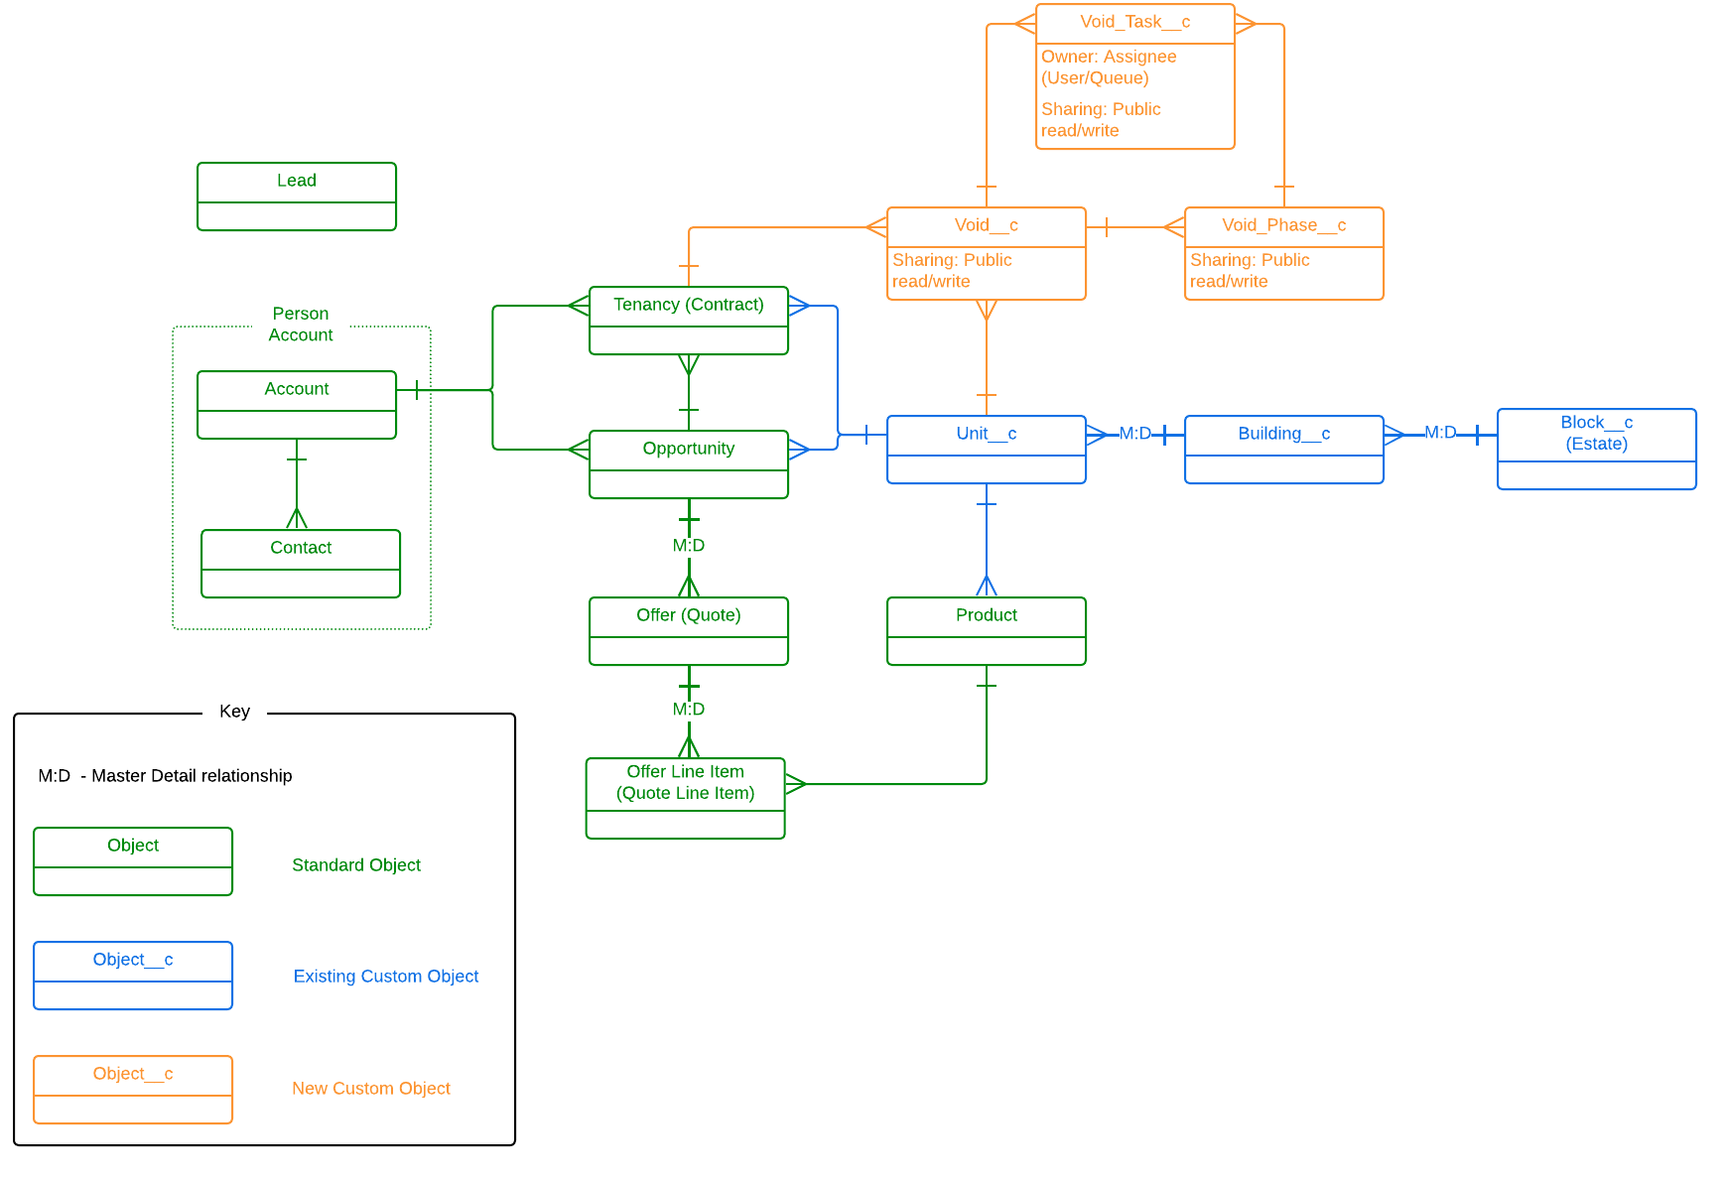
Figure 9: Entity Relationship Diagram

Data Sharing & Security
The Grainger PLC Salesforce org currently has a public read/write org wide default (OWD) for all key objects (Account, Opportunity, Tenancy) and allows all users to view all records. Where no security requirements exist to restrict visibility, this solution provides full visibility to all users and facilitates easy collaboration (e.g. users are able to update tasks belonging to a colleague when the colleague is absent). Based on this, it is proposed that the Void Management objects will follow the same OWD and allow full access to all users. Should future requirements necessitate a tighter security model, this can be implemented with the many security mechanisms provided by Salesforce (role hierarchy, sharing rules etc.).

Integration Approach

Release 1 Integration Requirements
Functionality proposed for release 1 does not require any new integrations between Salesforce and other applications. Release 1 focuses on implementing the void management process within Salesforce, using tasks to track off platform activities (e.g. users will cancel a direct debit in the finance system and mark the Salesforce task as completed).
Existing integrations (e.g. Qube / Salesforce property master data) will be leveraged to ensure the Void Management process aligns with the overarching goal of providing a single view of the customer and property.

Roadmap – Future Integration
Future releases will include integrations to FSI, Qube, Hive and the Grainger Portal (and other systems as identified). Where possible, all integrations should be implemented via the GREP integration layer to:
- Ensure a decoupled architecture
- Take care of routing and error handling
- Fall under existing Grainger standard operating procedures (SOP)
- Support complex transformations
- Efficiently handle large data volumes
It is understood that various integration initiatives are already in progress (e.g. automated lease creation in Qube triggered by Tenancy in Salesforce). The Open Box implementation team should work closely with Grainger PLC to ensure the roadmap is aligned and supports the Void Management roadmap.

Data Migration
The current state Void Management process is largely manual. There is no source of void data that could be feasibly migrated to Salesforce. As the Salesforce Void Management solution goes live, users will start using it to create new voids. Any in progress voids should be completed using the current manual process.
All data is either assumed to already exist in Salesforce or will be created via the Void Management functionality. It is assumed that the existing Salesforce customer and property data is of a sufficiently high quality to support the Void Management process. No cleansing, enriching or de-duplication is planned.

Salesforce Licensing
It is understood that all users of the first release of the Void Management solution have already been provisioned with full Salesforce licenses. It should therefore not be necessary to purchase additional licenses.
It is not expected that the solution will require any additional costs for data and file storage. This is based on current understanding and scoped features and is subject to change if additional requirements (e.g. file storage) are introduced.
Future functionality may involve additional users (e.g. external contractors to be assigned inspection tasks), in which case requirements would need to be evaluated to determine the most suitable license types (e.g. customer community vs. customer community plus). Grainger PLC would need to purchase these from Salesforce.

Support
Open Box will provide post-go-live support for 10 working days immediately following the production deployment.
Where additional or ongoing support, enhancements and maintenance of the solution is required:
- A separate support agreement will be required, or
- If Grainger chose to extend Open Box’s services, support may be incorporated into the backlog.

Training
To facilitate the training process, Open Box will train a designated Grainger representative.
Open Box will not provide any end-user documentation, change management or end-user training; this will be the responsibility of Grainger.

Exclusions and Limitations
The following is not included in the cost or scope of this project:
- Multi language and multi-currency are not required for this solution.
- Solution documentation, other than user stories.
- Salesforce costs, license fees, subscriptions or services
- The following functionality is not expected to be required in the initial, or future, releases:
  - Different workflow between BTR & PRS properties
  - Document generation
  - Notifications are limited to creating tasks that users can see. There is no need to generate reminder/notification emails from the system.
  - Integration with:
    - Inventory Hive
    - Datawarehouse for reporting
    - Proactis (AP)
    - New integration with Adobe Sign
- Only the browsers detailed within Salesforce Help will be supported by the web solution.

Detailed Costs
Open Box will provide the following services:
- An agile sprint team delivering sprints at a cost of £35 100 per sprint.
  - Release 1 is currently projected to require 4 sprints (£140 400)
  - The team will be staffed to include the following skill sets as required:
    - Salesforce Technical Architect
    - Business Analyst
    - Developer
    - Quality Assurer
    - Project Managers
- UAT support at a minimum cost of £1, 800 per week.
  - Open Box has included 2 weeks (10 days) of cover to be provided to support the UAT process and fix any new bugs identified (£ 3 600).
  - UAT support will be billed for the duration of the UAT period (i.e., from the end of the final sprint until UAT sign-off by Grainger) on a pro-rata basis.
- Production deployment & and post-go live support at a minimum cost of £1 800 per week.
  - Open Box has included 2 weeks (10 days) cover to be provided immediately following the production deployment (£ 3 600).
The project is expected to start on 4th September 2023 and require 4 sprints to complete development as well as 2 weeks for UAT.
- The total cost of Release 1 is therefore estimated to be £ 147 600.
- The total duration of Release 1 is expected to be 14 weeks as well as an additional 2 weeks for post go-live support.

Release 1 Phases | Expected Start Date | Duration | Estimated Cost (GBP)
Sprint 1 | 4th September 2023 | 3 weeks | £ 35 100
Sprint 2 | 25th September 2023 | 3 weeks | £ 35 100
Sprint 3 | 16th October 2023 | 3 weeks | £ 35 100
Sprint 4 | 6th November 2023 | 3 weeks | £ 35 100
UAT | 27th November 2023 | 2 weeks | £ 3 600
Production Deployment & Post Go-Live Support | 11th December 2023 | 2 weeks | £ 3 600
Release 1 Total |  | 16 weeks | £ 147 600

All amounts are quoted in GBP (£) and exclude VAT, if applicable.
Project costs will be billed monthly, in arrears.
This quotation is valid until 31st August 2023. Open Box will require sign-off on this Statement of Work by this date in order to meet the anticipated 4th September 2023 start date.
All consultancy and all development work will be completed by Open Box offsite.
- It is not expected that the project requires Open Box resources onsite. Where onsite personnel are required, all reasonable expenses for travel and subsistence shall be reimbursed by Grainger. Open Box shall not bill any mark-up or administration fee onto any such expenses. Approval for expenses shall be obtained from Grainger prior to being incurred.

Extension of Service Period
The provision of these services may be extended - by mutual agreement of Open Box and Grainger PLC - at the rates above. Email communication is considered sufficient and binding for this purpose.

Dependencies
Costs and timelines are contingent on:
- Grainger PLC identifying the appropriate personnel and stakeholders to be involved in the project, and them available throughout the project, including participation in the activities (and within the timelines) detailed in the Delivery Approach.
- There are no other projects planned or in operation that may hinder this project.

Delivery Approach
The delivery approach will be based on the agile SCRUM framework. Iterative delivery is achieved through a series of 3-week sprints.
An agile delivery approach allows for the early delivery of outcomes and provides flexibility to adjust for any unforeseen opportunities or issues uncovered during the project.
A backlog will be maintained to track outcomes to be delivered and indicate priority of these outcomes relative to each other. The backlog will be a living artifact that will evolve as Open Box and Grainger collaborate and will serve as the single source of truth with regards to scope.
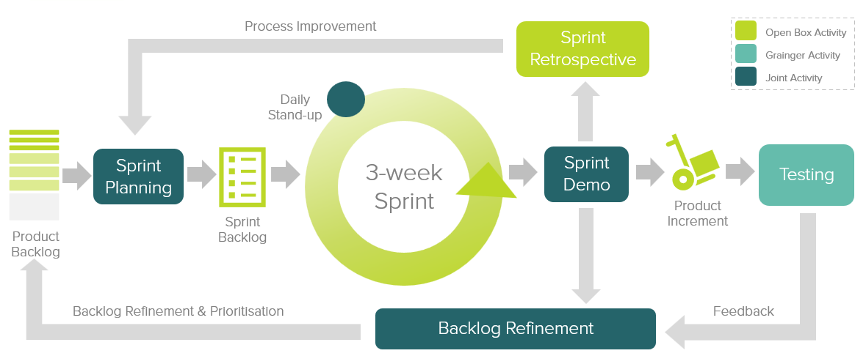
Figure 10: Agile Delivery Approach
Grainger representatives will be required to particulate in the following during each sprint cycle:
- Backlog Refinement – Open Box and Grainger representatives will meet to prioritise user stories on the backlog as well as review and agree on acceptance criteria for user stories at the top of the backlog.
- Demo – Open Box will meet with Grainger representatives to demonstrate the outcomes delivered in the past 3-week period.
- Sprint Planning – Outcomes on the backlog will be selected for the next 3-week period.
- Testing – Open Box will be responsible for unit testing and QA testing of functionality. Grainger representatives will conduct user acceptance testing of new functionality delivered in each sprint and provide feedback within 1 week of the demo.
- Stand Up’s – Regular, 15-minute stand up calls will be held to report on progress; the Grainger product owner is expected to participate regularly in these calls to provide feedback and give input on any questions that arise.
Grainger feedback from demos and testing will be classified as either bugs or enhancements (depending on the user story and acceptance criteria). Bugs will be fixed in a subsequent sprint, whereas enhancements will be incorporated into the backlog and prioritised accordingly.

UAT
Designated Grainger business users will be given access to a UAT sandbox to test the functionality end-to-end and ensure that the overall solution is functioning as expected.
Issues raised will be classified as bugs or enhancements (as above). Bugs will be fixed during the UAT period. Any other enhancements or new requirements will be added to the backlog for future development.

Project Management
Open Box will deliver a progress report to Grainger on a regular basis, that will include:
- General status update
- Project risks
- Project milestones and timeline forecast based on the current scope of release 1.
Regular updates regarding any significant changes in scope or cost will be delivered to Grainger as and when they occur.

Availability
- Open Box resources will be contactable and available for meetings via conference calls/video conferences:
- Monday to Friday 9AM – 6PM South African time (GMT +02:00) which currently corresponds to 8AM – 5PM (BST), excluding public holidays.
- A defined escalation path will be provided to the agreed Grainger project manager / product owner should urgent assistance be required outside of these times.

Acceptance
The parties hereto, each acting under due and proper authority, have executed this Agreement as of the day, month and year first written below.

For and on behalf of Open Box Software For and on behalf of Grainger

Signature: _____________________ Signature: _____________________
Name: _____________________ Name: _____________________
Position: _____________________ Position: _____________________
Date: _____________________ Date: _____________________

Appendices

Appendix A – Backlog for Release 1

Sprint 1
The user stories are expected to be addressed in Sprint 1, and are listed in order of priority.
Title | User Story | Acceptance Criteria | Points
A user can create a new EOT | As a Renewals, Onsite PM or Centralized PM user, I want to create a new End of Tenancy once the tenant has provided NTQ, so that the End of Tenancy process can begin. | WHEN the user is viewing a Tenancy in Salesforce  THEN a 'Create End of Tenancy' button will be visible (regardless of tenancy status or dates).  WHEN a user selects 'Create End of Tenancy'  THEN the user will be prompted to capture the following details required to create a End of Tenancy: XXX  GIVEN a user has entered all of the required fields above  AND all validations are met  WHEN the user selects Create  THEN a new End of Tenancy will be created  AND the user will be able to see the above details, as well as the following system-generated information, in the End of Tenancy Details screen. xxx | 5
Generate phases & tasks when a new EOT is created | When a new End of Tenancy is created, I want all the End of Tenancy phases to be prepopulated with tasks, so that users can see all the activities that will need to be completed for the End of Tenancy. | WHEN a new End of Tenancy is created  THEN the user will see the phases applicable to the End of Tenancy’s workflow, displayed in order  AND the user will see which phase is currently in progress  AND the End of Tenancy’s current phase will default to the first phase (i.e. Receive Notice).  WHEN a new End of Tenancy is created  THEN all tasks applicable to the End of Tenancy’s workflow will be created for the End of Tenancy  AND each task’s (un-editable) configuration will be copied into the End of Tenancy (including queue type, expected duration, and the dependency that determines when the task will start)  AND default task status will be ‘Pending’ | 13
Assign tasks to a responsible team | When a task is created, I want the task to be automatically assigned to a responsible team, so that there is clear responsibility for tasks. | WHEN an administrator is managing Building Details in Salesforce  THEN they will be required to specify a Task Team (i.e. a Salesforce queue / user group) for each of the following Queue Types:  Finance, Centralised PM, Onsite PM, Asset Management, Lettings, Maintenance, and Refurb Team.  WHEN a new void and associated tasks are created  THEN the task will be automatically assigned a Task Team (i.e. Salesforce queue) based on the task's Queue Type & Building setup above. | 5
A user can update EOT details | As a user, I want to capture key End of Tenancy information, so that other users looking at the End of Tenancy have access to relevant information. | WHEN a user is viewing the End of Tenancy Details screen  THEN, in additional to the fields detailed in FVVP-48 , the user will be able to add & update the following End of Tenancy information: XXX | 3
Calculate Estimated Timelines - Tasks Tied to an EOT Date | When a new void is created, I want all tasks that start on a specific date to have a start date & target end date based on the void dates that are currently known or estimated, as well as the expected duration for each task, so that users can plan ahead. | GIVEN a task is configured to start on Void Start Date  WHEN a new void and associated tasks are created  THEN the task's Start Date will be set to Void Start Date  AND the Task Status will be ‘Active’.  GIVEN a task is configured to start on PVI Date  WHEN a new void and associated tasks are created  THEN the task's Start Date will be set to PVI Date  AND the Task Status will be ‘Active’ where ‘PVI Date is Confirmed’ is checked, otherwise the Task Status will be ‘Pending’.  GIVEN a task is configured to start on Future Vacate Date  WHEN a new void and associated tasks are created  THEN the task's Start Date will be set to Future Vacate Date  AND the Task Status will be ‘Active’ where ‘Future Vacate Date is Confirmed’ is checked, otherwise the Task Status will be ‘Pending’.  WHEN a task is created  THEN the task's Target End Date will be calculated as [Start Date] + [Expected Duration]. | 5
Update Timelines - Tasks Tied to an EOT Date | When key void dates are updated or confirmed with the tenant, I want tasks dependent on those dates to reflect the correct dates & status, so that users have access to up-to-date void timelines. | GIVEN a task is configured to start on PVI Date  WHEN a user updates the PVI Date for a void  THEN the task’s Start Date will be updated to the new PVI Date  AND the task’s Target End Date will be recalculated.  GIVEN a task is configured to start on PVI Date  WHEN a user updates the ‘PVI Date is Confirmed’ checkbox  THEN the Task Status will be set to ‘Active’ where ‘PVI Date is Confirmed’ is checked, otherwise the Task Status will be set to ‘Pending’.  GIVEN a task is configured to start on Future Vacate Date  WHEN a user updates the Future Vacate Date for a void  THEN the task’s Start Date will be updated to the new Future Vacate Date  AND the task’s Target End Date will be recalculated.  GIVEN a task is configured to start on Future Vacate Date  WHEN a user updates the ‘Future Vacate Date is Confirmed’ checkbox  THEN the Task Status will be set to ‘Active’ where ‘Future Vacate Date is Confirmed’ is checked, otherwise the Task Status will be set to ‘Pending’. | 8
A user can see all outstanding tasks for an EOT | As a user, I want to see a list of tasks associated to a void, so that I am aware of the tasks required. | WHEN a user is viewing a void  THEN they will see a list of void tasks  AND the following details will be displayed per task: Task Name, Task Status, Task Owner, Start Date, Target End Date  GIVEN a task is in an ‘Active’ or ‘In Progress’ status  AND the task’s Target End Date has passed (i.e. is before the current date)  WHEN a user is viewing the list of void tasks  THEN there will be a visual indication that the task is overdue (e.g. red “!” icon) .  WHEN the void’s task list first initially loads  THEN by default, only tasks is a status of ‘Pending', ‘Active’ or 'In Progress’ are displayed  AND by default, tasks will be ordered by Target End Date (earliest dates at the top of the list).  WHEN a user is viewing a void’s task list  THEN they will be able to apply filters to search for a specific set of tasks  AND the user will be able to see any void task from the list (including complete tasks) | 3
A user can update task details | As a user, I want to update task details, so that a task can be assigned to a responsible person and task progress can be tracked. | WHEN the user selects a task from a EOT’s task list FVVP-190  THEN the user will be able to see and update the task details below: XXX | 3
Complete a phase when all underlying tasks are complete | Once all the tasks in a phase are complete, I want the phase to reflect as complete and the next phase to reflect as current, so that users do not need to check if they are the last person to complete a task in a phase and manually close the phase. | GIVEN that there is only one task remaining in the Current Void Phase that is not inactive and is in a Task Status of ‘Pending’, ‘Active’ or ‘In Progress’  WHEN a user updates the final task’s status to ‘N/A’ or ‘Complete’  THEN then Current Void Phase will be updated to the next sequential phase  AND the user will see the last phase reflecting as complete and the next phase reflecting as current on the void screens. | 5

Sprints 2-4
The following features are expected to be addressed in the remainder of Release 1, and are listed in order of priority.
Feature | Notes | Points | Estimated Sprint
Calculate Estimated Timelines – Tasks dependent on completion of prior tasks | Tasks dependent on a phase are configured as dependent on multiple prior tasks.  - Calculate task’s estimated start & end date. | 5 | 2
Update Timelines – Tasks dependent on completion of prior tasks | - Update task’s estimated start & end date.  - Update task status & actual start date when ready to be worked on.  - Ignore tasks marked as N/A. | 5 | 2
Users can see estimated unit available date & EOT completion date | Calculate the unit’s estimated available date & overall EOT completion date.  - Available date = last day of all refurb / refresh / clean tasks.  - Automatically update as EOT info is updated.  - Users should be able to see the actual available & completion dates once known.  - Ignore tasks marked as N/A. | 3 | 2
Users will only see refurb & refresh tasks where applicable | Certain tasks will only be displayed where the unit is due to be refreshed; other tasks will only be displayed where the unit is due for refurbishment. This indicator may be changed after PVI and the associated tasks will be displayed/hidden accordingly.  - Update the unit’s available date as well.  - All units require a clean task.  - Update timeline & available date / completion date | 3 | 2
Users will see only relet tasks where applicable | Certain tasks will only be displayed where the unit is flagged to be relet, and will be removed from the workflow where this indicator is changed.  - Relet & sale are not mutually exclusive.  - Relet status may change mid-workflow. Tasks should show/hide accordingly.  - Update timeline & available date / completion date. | 3 | 2
Close an EOT where all tasks are complete | Closes automatically. | 1 | 2
Users can cancel an EOT | Ability to cancel an EOT mid workflow e.g. where a tenant rescinds NTQ or EOT is created in error / for the wrong unit. | 2 | 2
Migrate task queues onto building setup | Prepopulate new building setup based on a once-off data migration:  Finance, Centralised PM, Onsite PM, Asset Management, Letting, Maintenance, Refurb. | 3 | 2
Users can see detailed tasks | Configure detailed tasks / task information displayed to users.  Replace the 'Notify the Council Tax & Water Company’ task in FSI MiMo task? | 2 | 3
Users will be required to complete key information when completing tasks | Prompt users to capture the actual PVI date, DRI form & other required details before the Confirm Notice phase can be completed.  - Move details from MiMo task into EOT process, e.g.: such as deposit resolution, amount of deposit stopped, deposit return date, actual move out date, reason for vacancy. | 3 | 3
Users can see task lists | Provide EOT -related task lists that will notify users and teams of upcoming work, as well as tasks that are ready to be worked on.  - See tasks for an entire team.  - See tasks for an individual user.  - Need to be able to differentiate between future tasks & tasks ready to be worked on.  - Tasks appear in user’s task list based on the actual start date; not based on current phase. | 3 | 3
Salesforce unit details are updated from the EOT | Automatically update Salesforce unit data (such as unit status and future vacate date) with EOT -related information, once key EOT milestones have been met.  - Once NTQ confirmed > Update unit status & FV date  - If Unit to be relet > Update available date  - Refurb/refresh affects unit status.  - Keep continually updated.  - Display viewing arrangements & key location on the unit for Lettings to access. | 5 | 3
Users can upload documents to an EOT | Enable users to upload EOT -related documents and access those documents when viewing the EOT or associated tasks. | 3 | 3
Replace internal notification emails | Notify internal teams and users of new EOTs of interest to them and associated responsibilities, through EOT tasks and dashboards  - Much of this may already have been addressed through tasks & dashboards.  - Users should be able to click through to the unit and see EPC & Gas Safety certificates in Salesforce.  - Links to marketing material e.g. floor plans is already on unit.  - Remove the Future Vacant Email from the FSI MiMo task.  - If a property/unit is flagged with a strategy to sell in Salesforce, Asset Managers need to see once an associated NTQ is confirmed in order to know to start the sales process.  - Lettings need to see confirmed NTQ where unit is due to be relet. | 8 | 3
Managers can access reports & dashboards | Provide reports and dashboards that give visibility into:  - KPI's (actual vs target task duration)  - Compare notify stakeholders, refurb & refresh timelines to targets.  - Deposit return timelines (days after move out per legal requirements)  - See overdue tasks / tasks ready to be worked on that are behind schedule.  - Identify EOTs behind schedule. View by property/estate.  - Workload for users and teams. Be able to see where teams have a high number of tasks coming up in future. | 21 | 4
A property manager can view onsite EOT tasks on a Property Calendar | Display a calendar per property of all onsite EOT tasks that will assist property management in scheduling onsite work | 5 | 4
A property manager can see all current EOTs for a building | Provide a view of all current EOTs for a building. | 3 | 4
A property manager can see a history of EOTs for a unit | Provide a view of current & prior EOTs for a unit that shows a history of turnaround times and when last a unit was refurbished or refreshed. | 3 | 4
A user can see an audit history of updates to EOTs & tasks | Enable users to see a history of updates to EOTs and underlying tasks. | 5 | 4
A user can see reasons for key EOT updates | See a reason entered when updating FV or PVI dates.  See a reason required when setting task status to N/A. | 3 | 4
Calculate the target PVI date | Work back from the FV date and the expected duration of the PVI and Book Works phases. | 1 | 4

Appendix B – Backlog for Future EOT Releases
The following is a list of features identified for future releases of the EOT functionality. This list does not represent all required, future functionality.
Features are not listed in any order of priority
Feature | Notes
Integration with Qube | - Update Qube lease status, tenure & vacant due date from EOT.  - Update on key events / milestones e.g. on move out.
Integration with FSI | - Create / update MiMo & ICO tasks from the EOT  - Integrate FSI task status & task due dates back into the EOT.
Incorporating Expected Delays into Timelines
Add Custom, User-Defined Tasks | To allow for exceptions e.g. additional compliance action required.
Capture Detailed Works Required & Create Resultant Tasks | - Create a list of works required at PVI, i.e. a list of items, not a single, large text field.  - Option to add to list after tenant moves out.  - Add photos.  - Create a task for each work item required – to be completed when works are booked.  - See a history of detailed works on the unit.
Detailed Refurbishment Tasks
Replace the Existing PVI Checklist in FSI | Move PVI checklist out of FSI?  Ability to attach photos.
Upload Compliance Certificates & EPCs with Expiration Dates | Need to be able to easily see if new Compliance Certificates (including EPC & EICRs) are required when looking at a unit in SF based on expiration dates.
Online Tenant Instructions – Notice to Quit | Add to tenant portal.
Online Tenant Instructions - Deposit Return Instructions | Add to tenant portal.  Need to link DRI to Qube lease ID for Finance.
Advanced Dashboards - Trends & Comparison Analysis | Identify properties over- and under-performing.  Identify teams over- and under-performing.  Identify problematic activities/tasks consistently late.
Property Calendar - Incorporate Viewings
Property Calendar - Incorporate Non-EOT Activities | Building & unit-specific tasks e.g. lift maintenance happening onsite, water flushing.
Automatically Create Water Flushing Task from EOT | Shouldn’t be an EOT task & affect EOT timelines.
Customize Turnaround Times | Shorter refurb / refresh time for buildings with onsite maintenance teams.  Longer refurb / refresh turnaround time for:  - Older buildings  - Units not refurbed or refreshed in a long time  - Units with a long tenancy  This could be default in future once there is a more comprehensive refurb/refresh history.
Incorporate Non-Working Days into Task Due Date | Incorporate weekends & bank holidays.
Automate Emails To Tenants - Move Out Email | - Includes PVI date, key arrangements.  - Include links to webforms/online info with property/block-specific information.  - Remove the Move Out email functionality from the FSI MiMo task.
Automate Emails To Tenants – PVI Follow Up Email
Automate Emails To Tenants – Check Out Report
EOT Workflow - Garage/Parking Bay Only | Subset of tasks required if there is no unit being vacated.  Generates a different MiMo task
EOT Workflow - Tenant Has Already Vacated | May only require setup of a new workflow with a subset of phases & tasks.  Does not include Receive Notice phase & has a subset of the Check Out tasks. Would be able to capture actual PVI date upfront.
EOT Workflow - Landlord Gives Notice To Vacate | May only require setup of a new workflow with a subset of phases & tasks.
Tenant Rescinds NTQ | Additional / different activity required if tenant rescinds NTQ mid workflow.  - Create tasks to reverse updates / notify stakeholders  - Reverse Qube Updates  - Reverse updates to SF Unit  - Close FSI tasks (ICO task, manually created refurb tasks)
Automatically Assigning Tasks To Individual Users | Consider using Qube property setup that saves the PM Assistant, Block Manager, Senior PM, Asset Manager and Refurb/Development individual.

